Created Project:BookMyShow

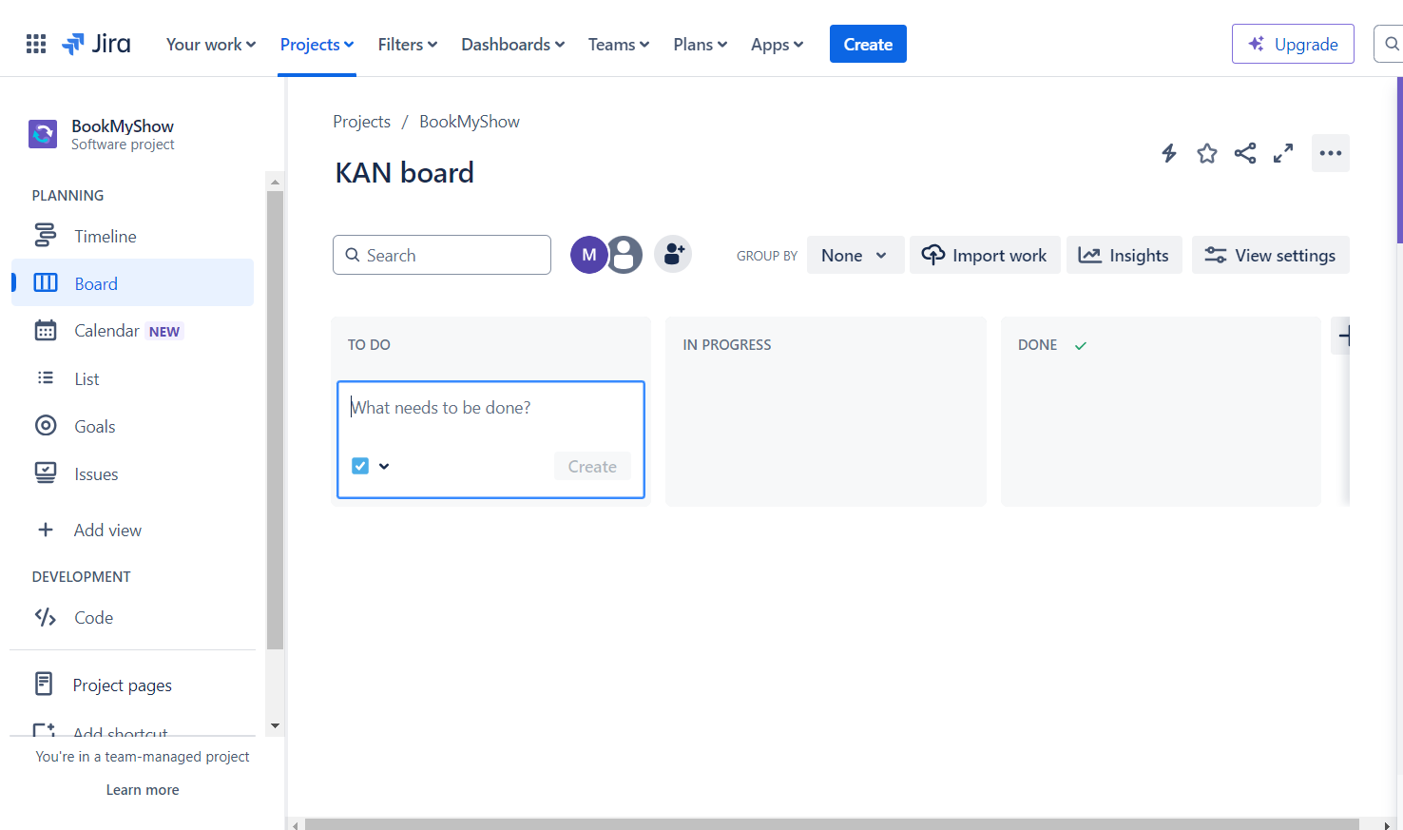

Created Epic

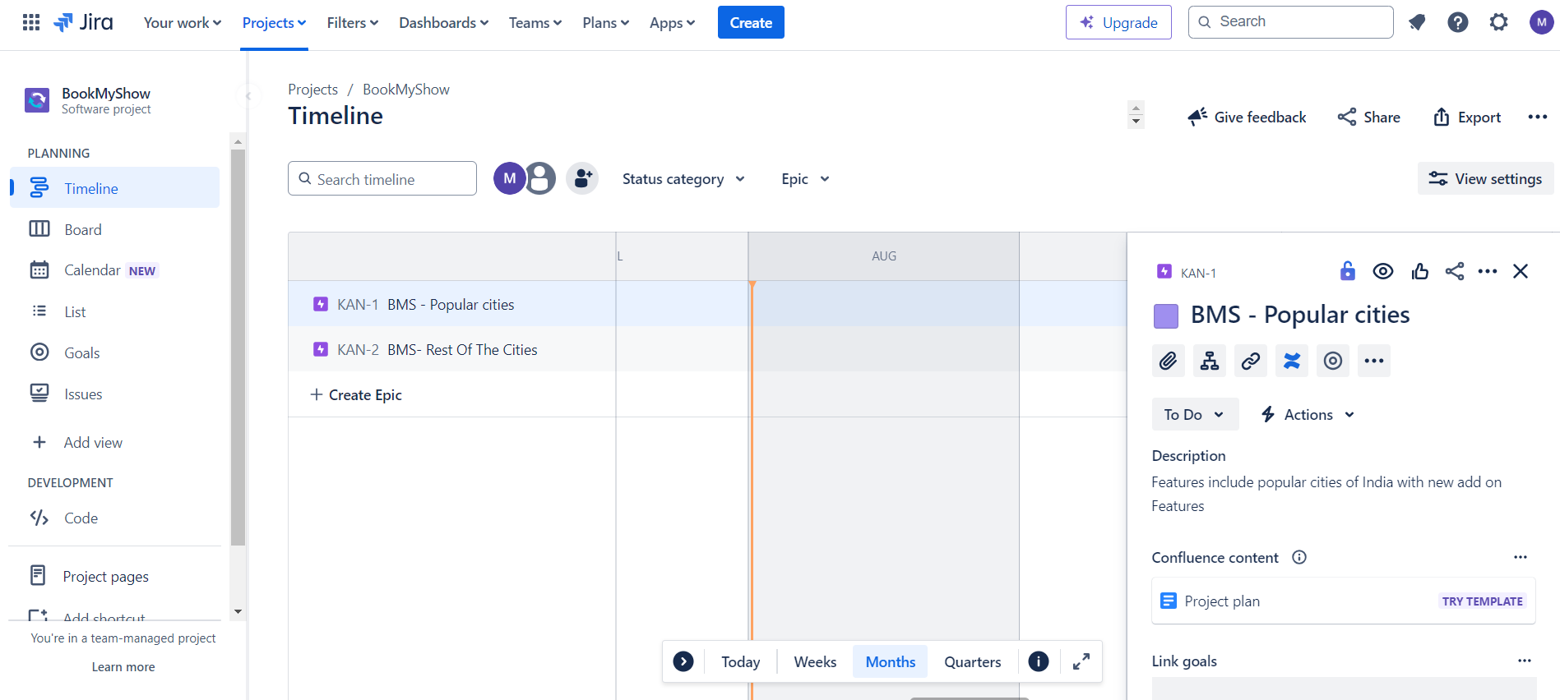

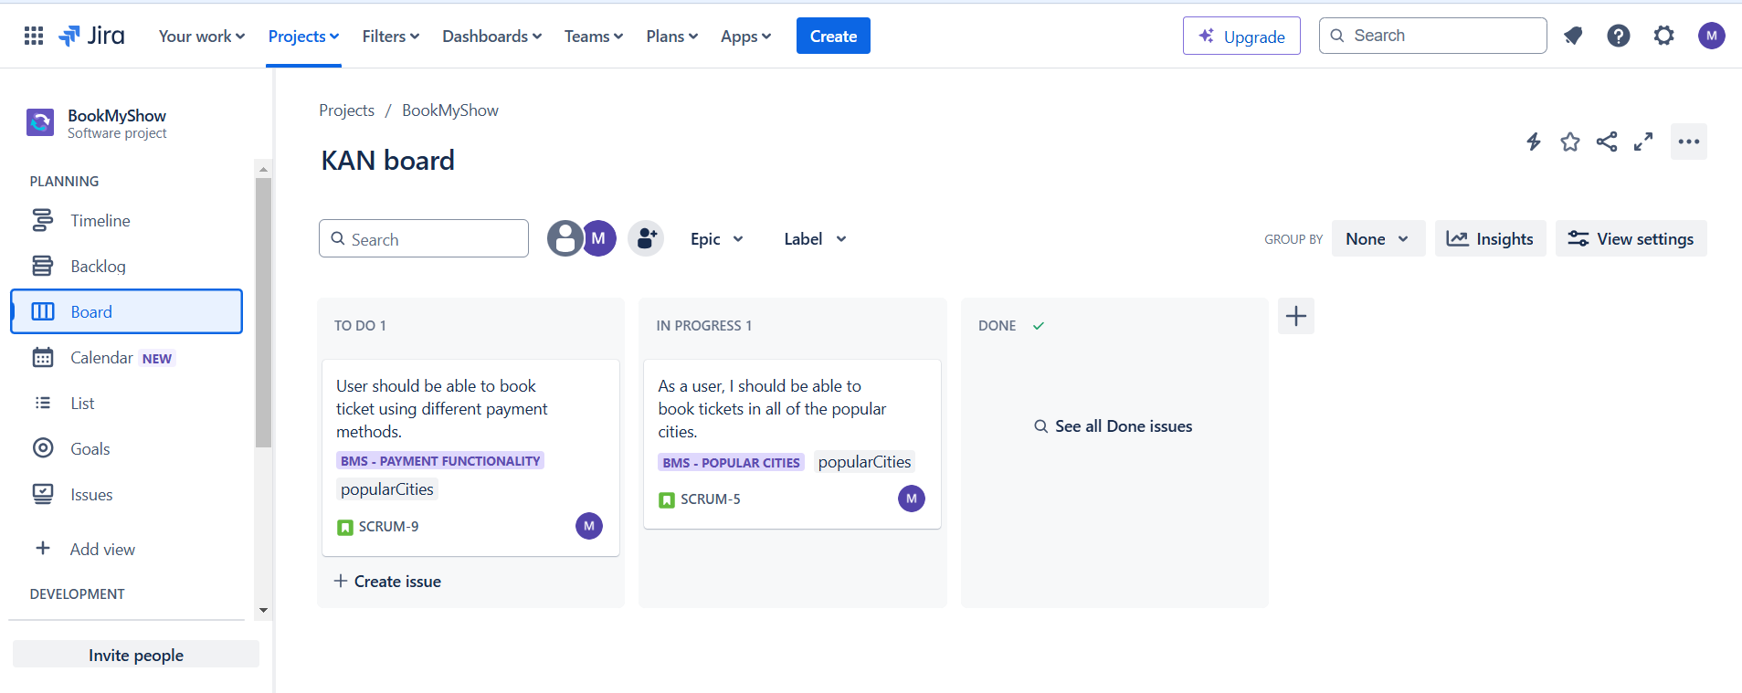

Backlog Board:

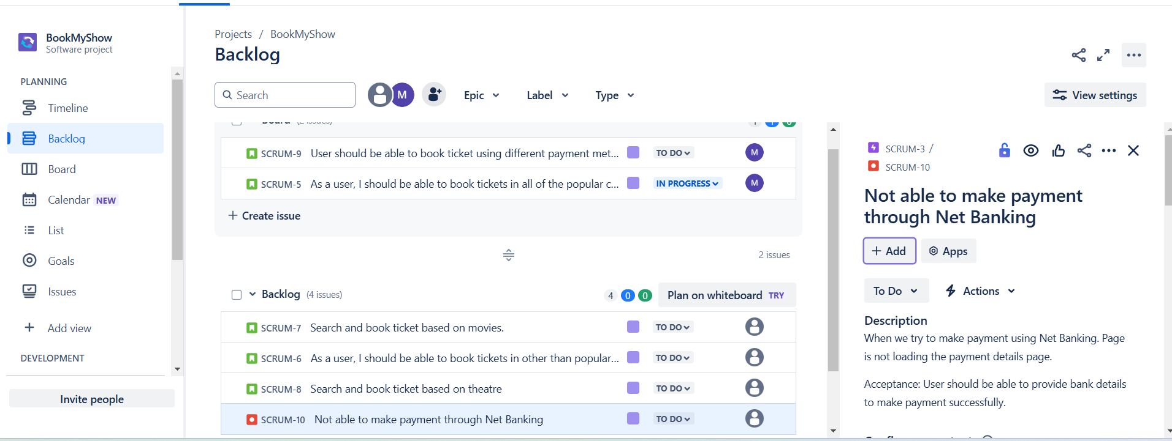

Bug:

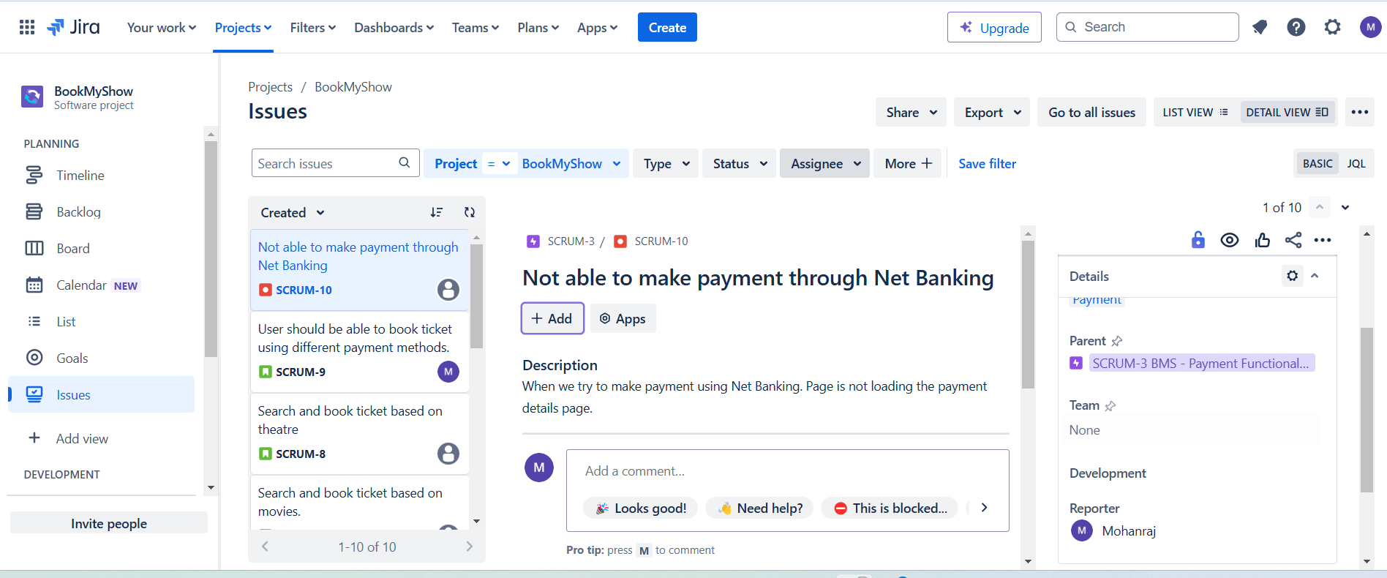

UserStory:

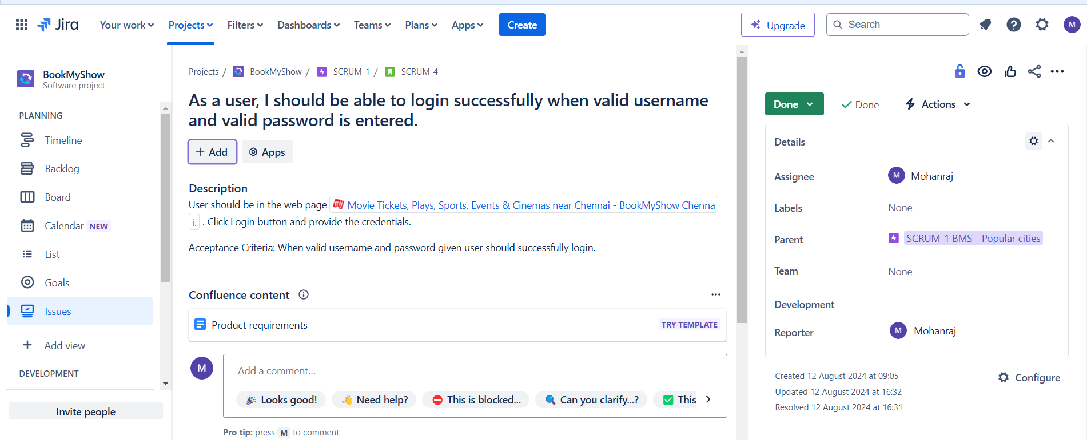

Test Scenario:

This is high level testcase. It is an idea of what we are going test.

Test case:

It is an idea of what we are going to test, it includes testcase(tc) name, test data, expected and actual result, status…etc

Test Strategy and plan:

It is a high level document which captures the approach on how we go about testing the product and achieve goals. It is developed by project manager.

Test plan are prepared keeping this document such as opt for manual or automation testing, number of resources used for project completion.

Test Summary Report:

Test summary report explains various details about testing cycles, project qualities and project situations to project manager and clients to decide

Whether if the application is ready to release with current sprint completed test cases.